[1]

Contactless Measurement of Human Systolic Time Intervals based on Doppler Cardiograms in Clinical Environment

Shuqin Dong, *Student Member, IEEE*, Li Wen, *Student Member, IEEE,* Zhi Zhang, Changzhan Gu, Senior Member, IEEE and Junfa Mao, Fellow, IEEE

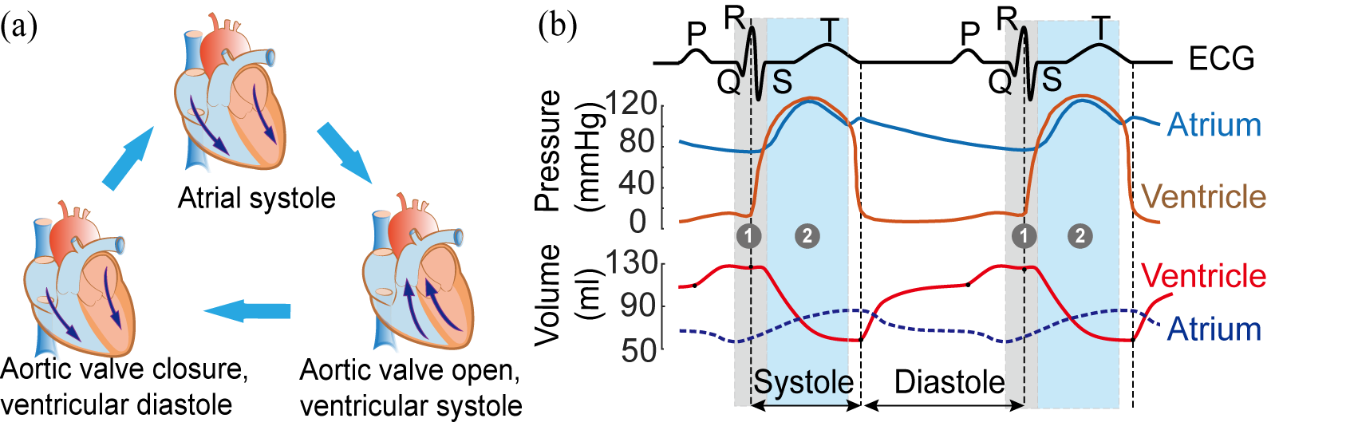

Fig. 1. (a) Cardiac cycle phases (b) Modified Wiggers diagram with grey zone indicating 1 (PEP) and blue zone indicating 2 (LEVT) [2].

***Abstract*—As the most important organ of human body, heart has many measures and indicators to assess the cardiac function in clinic. Of major relevance in providing crucial information regarding cardiovascular state are ventricular systolic time intervals (STIs). However, the existing measurement technologies are costly, complicated to operate, and also require contact sensors. Based on the human cardiovascular model and principle of Doppler cardiogram (DCG), the differential Doppler cardiogram (D-DCG) and quadratic differential Doppler cardiogram (QD-DCG) carry the aortic pressure information by which the STIs can be calculated. A 24-GHz digital dc-tuning Doppler radar sensor (DRS) has been implemented to detect the accurate DCGs. To assess the feasibility of contactless measurement of the STIs by DRS, clinical experiments and evaluations are carried out in the operation theatre. The pre-ejection period (PEP) and the left ventricular ejection time (LVET) estimation results reached 95.23% and 93.12% accuracy, which indicates the proposed method has great potential to be used for STIs estimation and could be convenient for patient home monitoring.**

***Index Terms*—STIs, D-DCG, QD-DCG, Doppler radar sensor**

# I. INTRODUCTION

F

OR human health monitoring, heart activity detection is always the most important research topic for medical and related researchers. Measurement of the rhythmic time intervals of cardiac cycle offers a quantifiable method to assess cardiac function. Among them, estimation of heart systolic time intervals (STIs) attracted the most interests due to its clinical value [1].

The STIs represents the duration of total electro-mechanical systole with two commonly used time intervals, i.e. PEP and LVET [1]. The determination of STIs offers an efficient method to study changes in left ventricular performance and the effects of therapeutic interventions or diseases on myocardial performance [1]. PEP and LVET have been known to be useful for evaluation of cardiac function. Specifically, the PEP/LVET ratio has been shown to be the most sensitive index of ventricular function [2]. In addition, the PEP can be used to improve blood pressure estimation based on pulse arrival time [2].

In the past decade, STIs were traditionally assessed by simultaneous recording of an electrocardiogram (ECG), phonocardiogram (PCG) and carotid pulse tracing using a multi-channel photographic recording system [2], the operation is complex. Several technologies reported recently use Doppler echocardiograpy or impedance cardiography (ICG) to measure STIs [1]. All these methods require multiple contact sensors, making it unsuitable for daily healthcare and burn victims, also increase the complexity of doctors’ operations in the clinical environment like operation theatre (OT).

Due to the non-contact advantage of Doppler radar sensor, recently, the Doppler signal which induced by the heart mechanical motions conducted to the skin on the chest, can be detected by remotely measuring via Doppler radar senor, and offers a temporal characteristic points (CPs) which are corresponding to the P wave, QRS wave and R wave of ECG. Such signal was named as “DCG” in [4].

In this work, based on the analysis of human heart model, it is found that the D-DCG and QD-DCG carry aortic blood flow timing information corresponding to the time of aortic valve opening which can be used to calculate STIs. To assess the feasibility of these DCGs to measure STIs, a K-band 24-GHz dc-coupled Doppler radar sensor was designed firstly for accurate detection of DCGs, then, an adaptive signal extraction algorithm is proposed to obtain the DCGs in the presence of normal breath. Finally, the clinical experiment is conducted in OT, the ECG and aortic blood pressure are recorded by multi life-parameters monitor simultaneously as a reference. Aiming at noncontact, flexible measurement method, an agile DRS is implemented including signal assess the feasibility of measuring the STIs. The experimental results showed that the detected DCGs is aligned very well with the reference signals. And calculated STIs by contactless Doppler radar sensor have high accuracy with reference to ground truth.

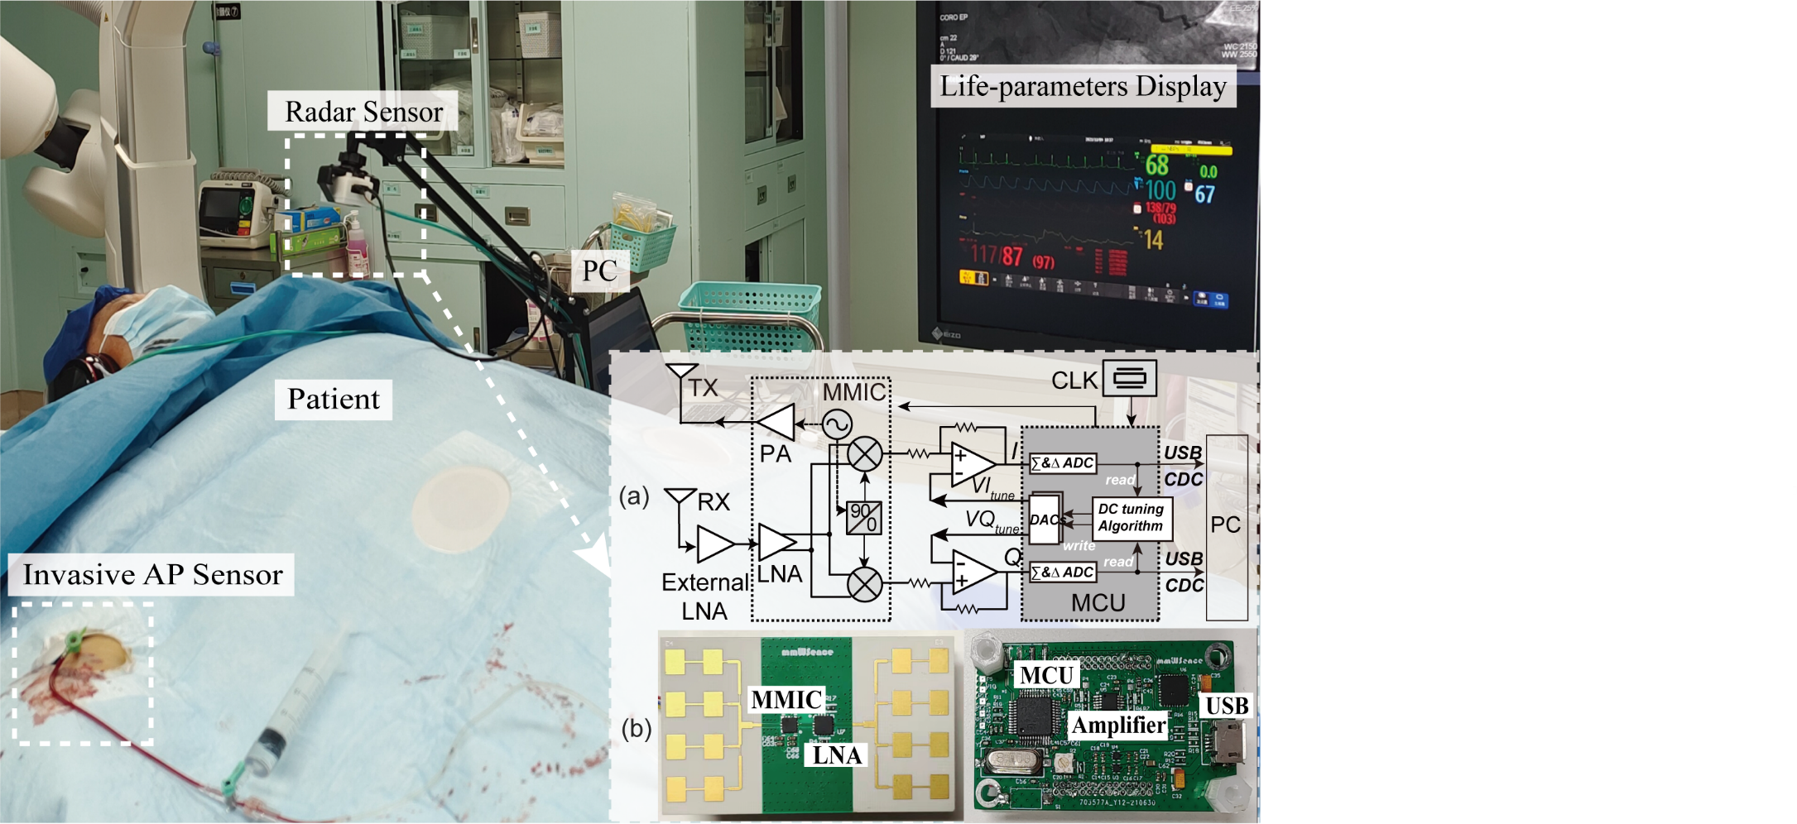

Fig. 3. Experimental setup in OT. (a) System block diagram of the 24-GHz radar sensor. (b) The implementation of 24-Ghz radar sensor.

# II. Theory

## A. Principle

In cardiology, the cardiac cycle contains a complete contraction and relaxation of both the atria and ventricles which take place in an ordered sequence. In Fig 1(a), the different phases of the cardiac cycle are represented. Fig. 1(b) shows the modified Wiggers diagram, which provides a comprehensive view of relationships between the phases and components of cardiac cycle. As illustrated in the diagram, according to the widely used STIs’ definition, PEP is the time interval between the Q point of the ECG and the opening of the aortic valve, corresponding to the point at which rising begins of aortic pressure waveform. And LVET is the time interval between the opening of the aortic valve and its subsequent closure [1], corresponding to the interval from rising beginning to the notch in the aortic pressure waveform.

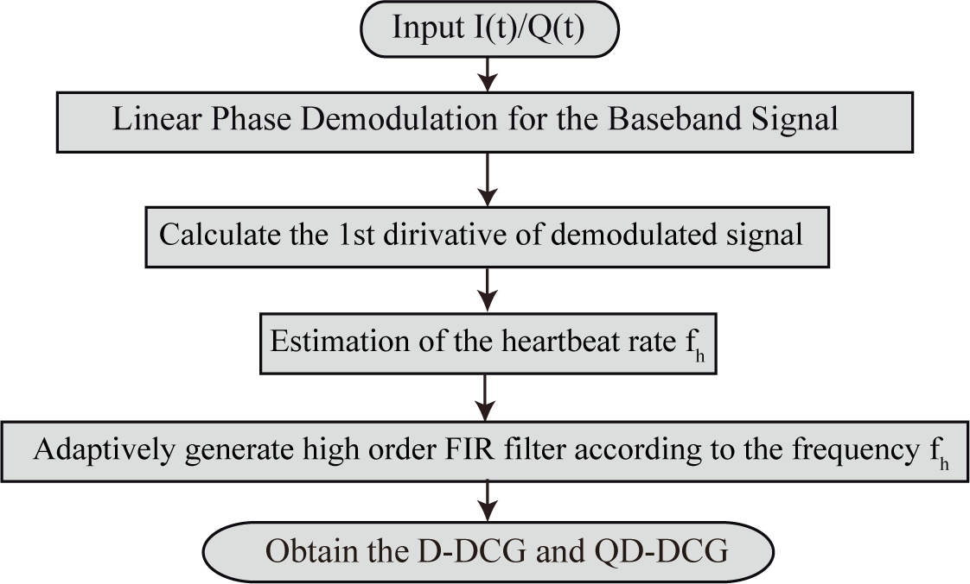

Fig. 2. Flow chart of the proposed adaptive D-DCG extraction algorithm.

The Teichholz model is a widely used heart model in medicine, it describes human heart as a biplane, long-axis ellipsoid. The temporal volume *V*(*t*) can be modelled as

*V*(*t*)*=*7*D3*(*t*)*/*(*D*(*t*)*+*2.4) (1)

, where *D*(t) is the temporal length change of the model’s short axes [3]. According to the heart position in human body, the length change *D*(t) will cause the human chest displacements via tissues which is named DCG in [4]. So the volume change *V*(*t*) can be obtained by this model. Subsequently, the Windkessel model reveals the relationship between blood pressure *P*(*t*) and blood flow in the aorta. The flow of blood *i*(*t*) from the heart is given as [5]:

 (2)

, where *P*(*t*) is the blood pressure in the aorta, *C* is arterial compliance, *R* is the peripheral resistance of the arterial system, *r* is the resistance to flow and *R1* is the characteristic aortic impedance.

In physiology, the left ventricular, which has the biggest volume of the heart’s four chambers, its contraction forces oxygenated blood through the aortic valve to be distributed to the entire body [5]. The ventricular volume change *V*(*t*) results in the blood flow to the aorta, and its 1st derivative result should have a correlation with the blood flow to aorta [5]:

$i(t)∝V'(t)$ and $\frac{di(t)}{dt}∝V''(t)$ (3)

Therefore, the DCGs (D-DCG and QD-DCG) should have correspondence with aortic blood pressure from which can acquire the timing information of aortic valve activity.

## B. Algorithm

For a zero-IF Doppler radar sensor, the mixer outputs *I*(*t*) and *Q*(*t*) signals can be expressed as follows:

 (4)

 (5)

, where *AI* and *AQ* are the amplitudes of the quadrature *I/Q* signals, respectively, *DCI*/*DCQ* are the *DC* offsets, *φ0* is the initial phase of the radar system, *x*(*t*) is the target motion, λ is the wavelength of the radar carrier, and Δ*φ* is the residual phase noise.

Aiming to linearly recover the target motion *x*(*t*) with no distortion, (4)/(5) have to be calibrated to remove the DC offsets by fitting the *I/Q* signals on the unit circle using compensation techniques [6]. Then the heart motion *x*(*t*) can be reconstructed by applying MDACM algorithm [8].

During the detection of human vital sign, the recovered target motion *x*(*t*) usually contains human cardiac and respiration components. In the normal breath scenario, the respiration waveform is generally very smooth, its fundamental frequency is between 0.2-0.4Hz, and doesn’t contain many higher harmonics [7]. Therefore, using a suitable high pass filter can filter out most of the respiratory signal.

In this paper, an adaptive digital finite impulse response (FIR) high pass filter is designed to remove the respiration. The cut-off frequency *f*c of FIR filter is adaptively determined by differential signal spectrum estimation of demodulated human motion. Then, *f*c is selected to be (*f*h-0.1) Hz. The transition band of the designed filter is 0.1 Hz, and the stopband attenuation is 80 dB. By leveraging the FIR Equiripple method, the desired FIR filter can be constructed with advantageous computational efficiency. After the filtering process, the D-DCG signal can be fully retrieved in the presence of human respiration. And if needed, DCG signal can be obtained by integrating D-DCG signal.

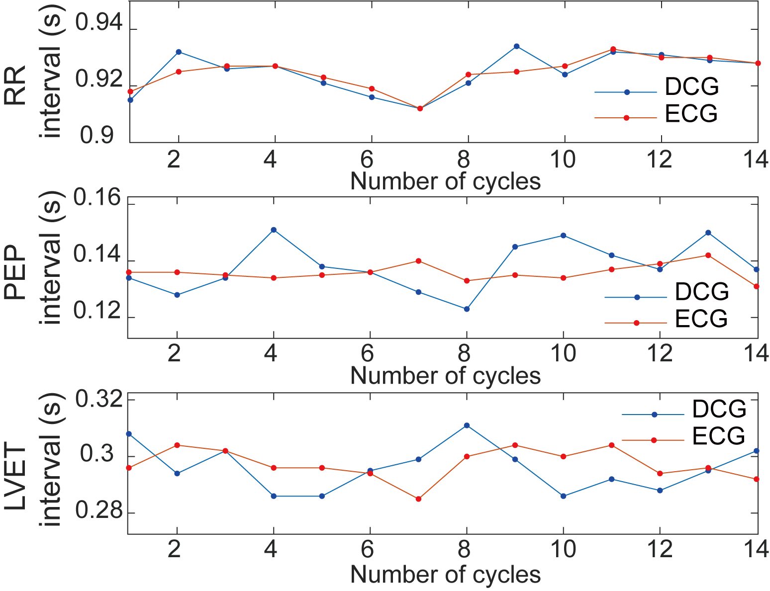

Fig. 5. Comparison between the time intervals retrieved from the D-DCG/QD-DCG and reference signals: (a) RR, (b) PEP, and (c) LVET.

# III. Experiments and Discussions

Fig. 3 (a) shows the detailed block diagram of the Doppler radar sensor developed for measuring the DCG based on a 24-GHz front-end silicon germanium millimeter-wave integrated circuit (MMIC), SGR SPK1101A. And an additional K-band low noise amplifier Silicon radar LNA_024_005 is employed to improve the noise figure performance of the receiver. The I/Q signals sampled by the embedded 16-bit sigma-delta analog-to-digital convertors (SDADCs) inside the microcontroller unit (MCU) STM32F373CCT6 can be transmitted to a computer with full-speed USB interface.

In addition, a low-complexity dc tuning algorithm running in MCU is proposed, as shown in the grey zone in Fig. 3 (a), to make full use of the sampling range of the ADCs with no need to add any hardware. In Fig.3 (b), the photo shows the implemented board-integrated radar system according to the block diagram in Fig.3 (a).

The experiment was conducted at the bedside in a hybrid operation theatre (OT) on a 45-year-old female patient. The scheme of the clinical experiment set-up is shown in Fig. 3. A patient multi-parameters life monitor, Philips MP2 M8102A, is used for patient in this OT. This monitor can simultaneously record the electrocardiogragh (ECG), invasive arterial blood pressure (ABP) and other life-parameters. The patient has just finished the angiography operation and is in the postoperative observation period, at which time the life-parameters monitoring was still working and the invasive aortic pressure sensor was not removed. The DCGs measurement was conducted from the front of patient with supine posture without requirement for patient movement. The ECG, AP and radar signal recording were simultaneously made for comparison purpose while the patient is in supine position with normal breath, so that the STIs measured by DCGs can be convincingly verified. The written informed consent was obtained from the patient.

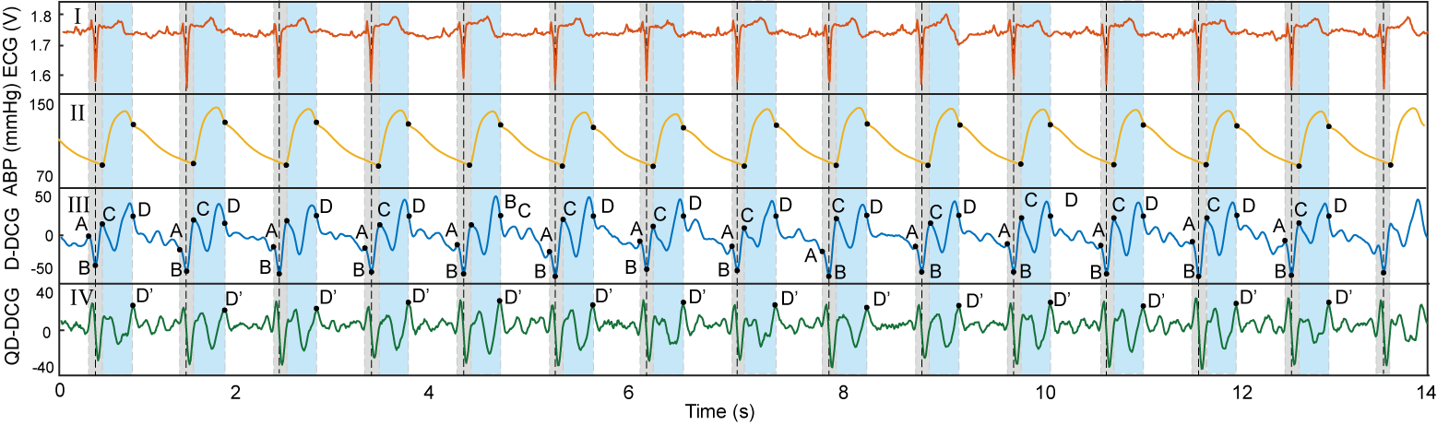

Fig. 4. Comparison between the measured D-DCG and the reference signals measured by multi life-parameters monitor in OT.

Fig. 4 shows the 14-second record of the experiment. The R peak denoted by vertical dash line of ECG is corresponding to the minimum point of D-DCG which means the maximum blood flow velocity. PEP and LVET are annotated in blue and grey zone, respectively. The characteristic points A to D/D’ are denoted in panel III and IV of Fig 4. It is noted that the point D’ located on a peak of QD-DCG is need to determine the point D which is corresponding to the closure of aortic valve. Other points A-C indicate the time information of ECG Q-wave, the ECG R-peak, the opening of the aortic valve, respectively.

Fig 5. shows the comparison between the STIs retrieved from the DCGs and reference signals. The root mean square error (RMSE) and the mean absolute percentage error (MAPE) of PEP and LVET are 8.6ms/6.35% and 9.5ms/3.2%. Besides, to compare the accuracy of the detected DCGs with respect to ECG, the R-R intervals detection error is also calculated, which is 3.5ms/0.38%.

# IV. Conclusion

In this work, the feasibility of contactless measurement of STIs using DCGs is demonstrated in clinical scenario. A K-band, board-integrated dc-coupled Doppler radar sensor and life multi-parameters monitor in OT were simultaneously employed to verify the arguments. The experiment results show the designed radar system and proposed algorithm have a promising potential to be used for STIs estimation.

References

1. Tavakolian, K. Systolic Time Intervals and New Measurement Methods. *Cardiovasc Eng Tech* 7, 118–125 (2016)..
2. Reant, P., M. Dijos, E. Donal, et al. Systolic time intervals as simple echocardiographic parameters of left ventricular systolic performance: correlation with ejection fraction and longitudinal two-dimensional strain. *Eur. J. Echocardiogr*. 11(10):834–844, 2010.
3. L. E. Teichholz, “Problems in echocardiographic volume determinations: echocardiographic-angiographic correlations in the presence or absence of asynergy,” *Am. J. Cardiol.*, vol. 37, no. 1, pp. 7-11, Jan. 1976.
4. S. Dong et al., “Doppler Cardiogram: A Remote Detection of Human Heart Activities,” *IEEE Trans. Microw. Theory Techn.*, vol. 68, no. 3, pp. 1132-1141, Mar. 2020.
5. Paola Molino, et al. “Beat-to-beat estimation of windkessel model parameters in conscious rats”, *American Journal of Physiology-Heart and Circulatory Physiology* 1998 274:1, H171-H177.
6. S. Bi, X. Gao, V. M. Lubecke, O. B. Lubecke, D. Matthews and X. L. Liu, "A Multi-Arc Method for Improving Doppler Radar Motion Measurement Accuracy," *2018 IEEE/MTT-S International Microwave Symposium - IMS, 2018*, pp. 244-247.
7. Y. Xiong, et al. "Accurate Measurement in Doppler Radar Vital Sign Detection Based on Parameterized Demodulation," *IEEE Trans. Microw. Theory Techn.*, vol. 65, no. 11, pp. 4483-4492, Nov. 2017.
8. W. Xu, C. Gu and J. -F. Mao, "Noncontact High-Linear Motion Sensing Based on A Modified Differentiate and Cross-Multiply Algorithm," *IEEE/MTT-S International Microwave Symposium (IMS)*, Los Angeles, CA, USA, 2020, pp. 619-622.

1. This work was supported in part by the National Key R&D Program of China under Grant 2021YFA0715303, the Natural Science Foundation of China under Grant 62171277 and Grant 61831016, and Shanghai Municipal Science and Technology Major Project under Grant 2021SHZDZX0102. (corresponding: Changzhan Gu).

   S. Dong, L. Wen, C. Gu and J. Mao are all with MoE Key Laboratory of High-Speed Electronic Systems and MoE Key Laboratory of Artificial Intelligence, Shanghai Jiao Tong University, Shanghai 200240, China. Z. Zhang is with Shanghai General Hospital, China. (changzhan@sjtu.edu.cn).